**Responding to IBM's Market Entry - A New Perspective**

**Background**: Our client is a midsize training company that serves New England and the Atlantic Seaboard regions. It offers a variety of computer training and consulting services. Eastern just found out that IBM is going to enter its segment of the market. What does it do?

**Objectives**:

1. IBM's entry into the market should be avoided or minimised.
2. We must maintain our current market share.
3. Attract new clients and strengthen our market position.

**My Approach**:

As a newbie to the business sector, I handled this situation with a fresh perspective:

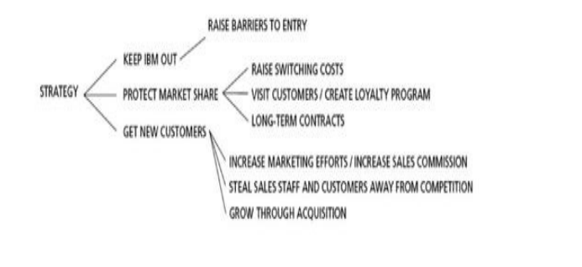

1. **Prevent IBM's Entry**:

Recognising the constraints of directly competing with IBM's resources, I advocated increasing our unique selling characteristics (USPs) to make it less appealing for IBM to enter.

We used our customer-centric approach and personalised service as a difference.

2. **Preserve Existing Market Share:**

I advised that we prioritise nurturing our existing customer connections.

Proposed approaches include the development of a cost-effective client loyalty programme.

Enhancing contact with clients is suggested in order to better understand their needs and develop stronger partnerships.

3. **Attract New Customers and Expand**:

As a newcomer, I was intrigued by innovative marketing methods.

It is advised to investigate digital marketing channels.

Participation in industry events and forums was advocated for in order to develop brand presence.

Recognised the possibility of collaborating with local educational institutions to reach new customer groups.

**Discussion**:

Despite the fact that I lack industry experience, I believe that new viewpoints can lead to creative solutions.

In the face of IBM's arrival, emphasised the importance of Eastern Training Network's fundamental qualities, such as personalised service and flexibility.

Price competitiveness was prioritised over client connections and distinctive selling factors.

**Conclusion:** Despite the fact that I am new to the subject of business analysis, I am eager to offer my ideas and energy to addressing difficulties such as IBM's entry into our market. To navigate the competitive landscape, I emphasise customer-centric tactics, creative marketing activities, and using our unique capabilities. I am confident that, even as a newcomer, I can make a significant

contribution to the growth of Eastern Training Network.